Devin Hardy

00076619

CS423

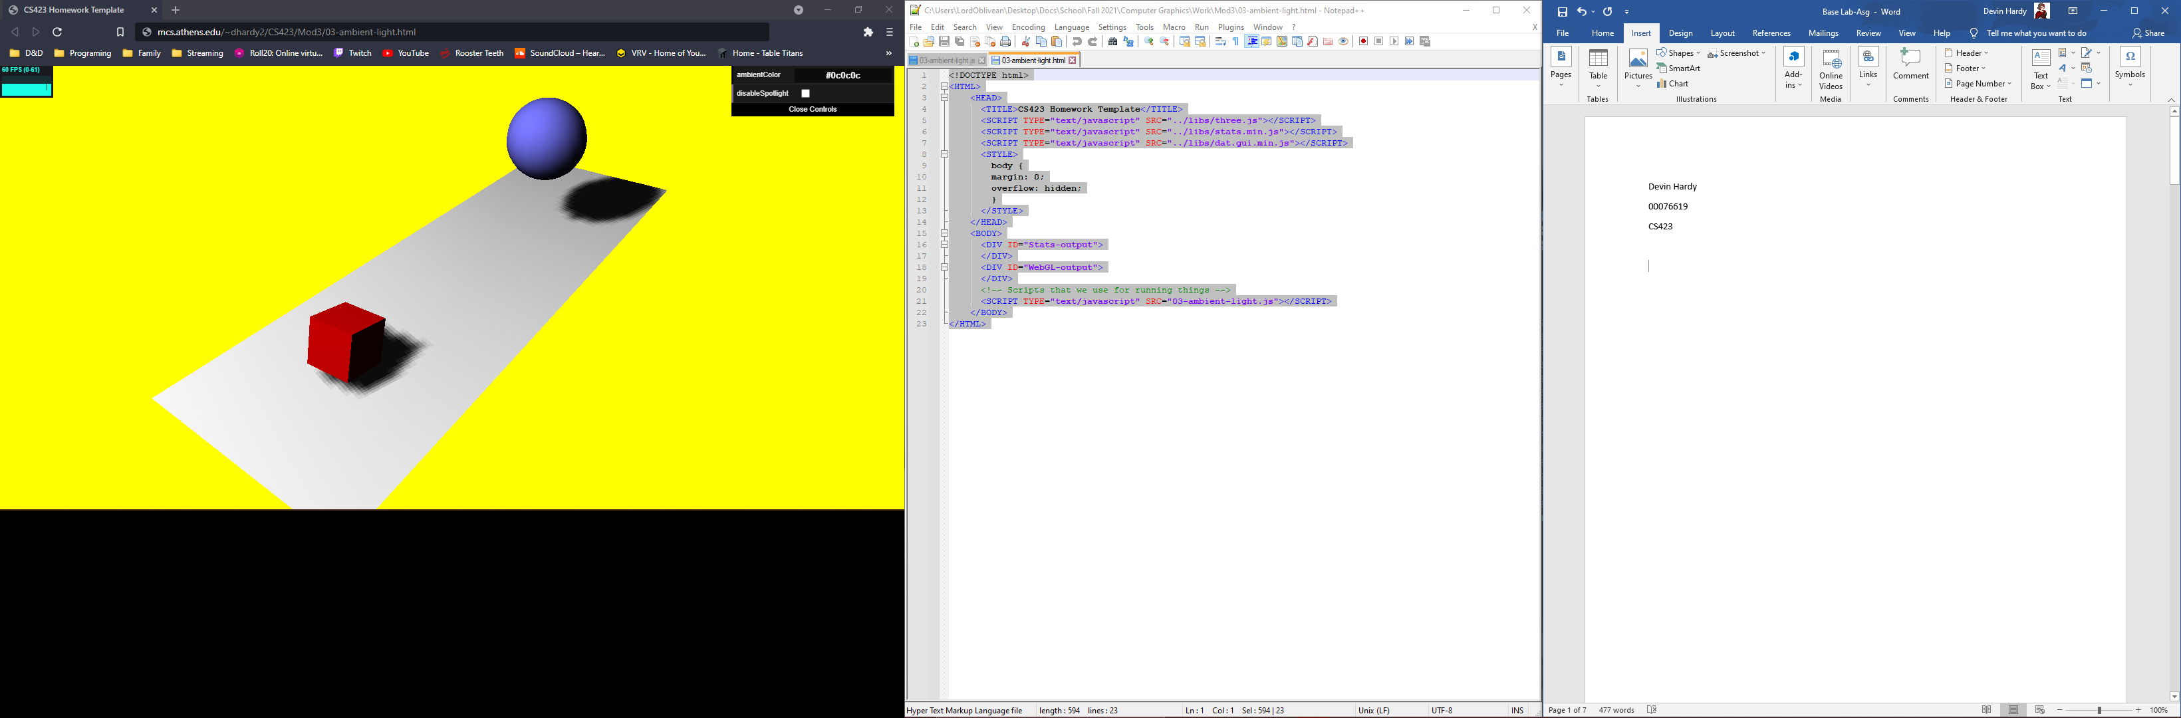

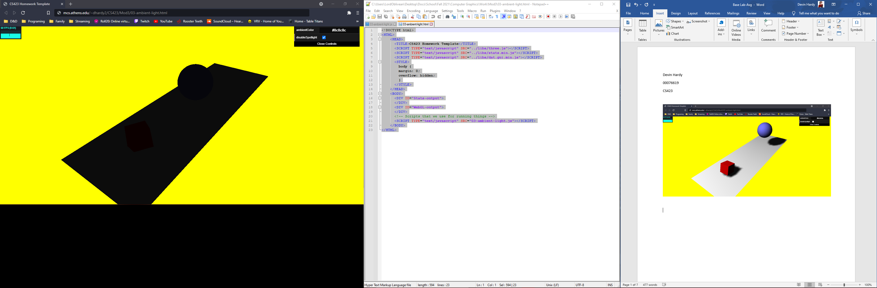

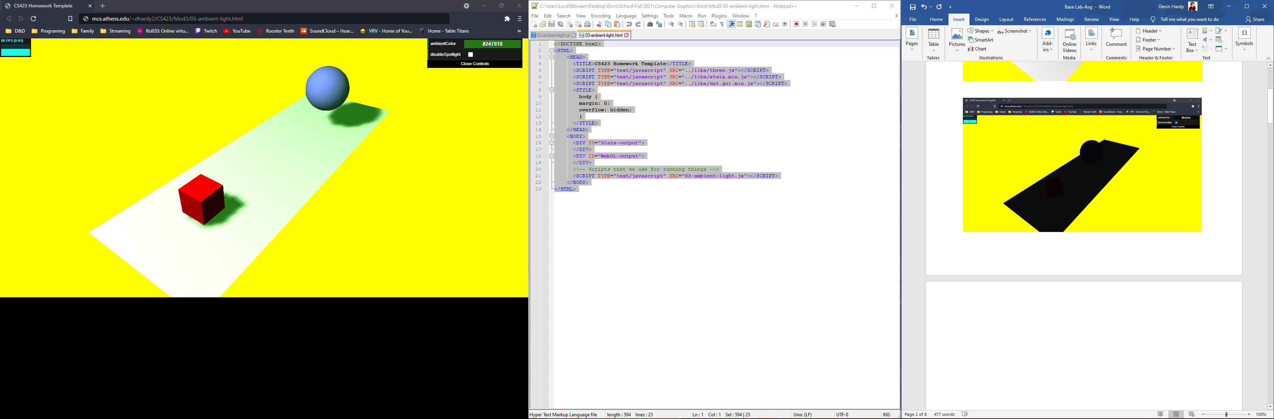

2.3 Your turn

1. The color change on the ambient lighting causes the material being used to reflect some of the color of the light.

2. When the material is basic it does not reflect light so it stays the color it has been set to.

<!DOCTYPE html>

<HTML>

<HEAD>

<TITLE>CS423 Homework Template</TITLE>

<SCRIPT TYPE="text/javascript" SRC="../libs/three.js"></SCRIPT>

<SCRIPT TYPE="text/javascript" SRC="../libs/stats.min.js"></SCRIPT>

<SCRIPT TYPE="text/javascript" SRC="../libs/dat.gui.min.js"></SCRIPT>

<STYLE>

body {

margin: 0;

overflow: hidden;

}

</STYLE>

</HEAD>

<BODY>

<DIV ID="Stats-output">

</DIV>

<DIV ID="WebGL-output">

</DIV>

<!-- Scripts that we use for running things -->

<SCRIPT TYPE="text/javascript" SRC="03-ambient-light.js"></SCRIPT>

</BODY>

</HTML>

function init() {

var stats = initStats();

// create a scene, that will hold all our elements such as objects, cameras and lights.

var scene = new THREE.Scene();

// create a camera, which defines where we're looking at.

var camera = new THREE.PerspectiveCamera(45, window.innerWidth / window.innerHeight, 0.1, 1000);

// create a render and set the size

var renderer = new THREE.WebGLRenderer();

renderer.setClearColor(new THREE.Color(0xEEEEEE, 1.0));

renderer.setSize(window.innerWidth, window.innerHeight);

renderer.shadowMapEnabled = true;

// create the ground plane

var planeGeometry = new THREE.PlaneGeometry(60, 20, 1, 1);

var planeMaterial = new THREE.MeshLambertMaterial({color: 0xffffff});

var plane = new THREE.Mesh(planeGeometry, planeMaterial);

plane.receiveShadow = true;

// rotate and position the plane

plane.rotation.x = -0.5 \* Math.PI;

plane.position.x = 15;

plane.position.y = 0;

plane.position.z = 0;

// add the plane to the scene

scene.add(plane);

// create a cube

var cubeGeometry = new THREE.BoxGeometry(4, 4, 4);

var cubeMaterial = new THREE.MeshLambertMaterial({color: 0xff0000});

var cube = new THREE.Mesh(cubeGeometry, cubeMaterial);

cube.castShadow = true;

// position the cube

cube.position.x = -4;

cube.position.y = 3;

cube.position.z = 0;

// add the cube to the scene

scene.add(cube);

var sphereGeometry = new THREE.SphereGeometry(4, 20, 20);

var sphereMaterial = new THREE.MeshLambertMaterial({color: 0x7777ff});

var sphere = new THREE.Mesh(sphereGeometry, sphereMaterial);

// position the sphere

sphere.position.x = 20;

sphere.position.y = 0;

sphere.position.z = 2;

sphere.castShadow = true;

// add the sphere to the scene

scene.add(sphere);

// position and point the camera to the center of the scene

camera.position.x = -25;

camera.position.y = 30;

camera.position.z = 25;

camera.lookAt(new THREE.Vector3(10, 0, 0));

// add subtle ambient lighting

var ambiColor = "#0c0c0c";

var ambientLight = new THREE.AmbientLight(ambiColor);

scene.add(ambientLight);

// add spotlight for the shadows

var spotLight = new THREE.SpotLight(0xffffff);

spotLight.position.set(-40, 60, -10);

spotLight.castShadow = true;

scene.add(spotLight);

// add the output of the renderer to the html element

document.getElementById("WebGL-output").appendChild(renderer.domElement);

// call the render function

var step = 0;

var controls = new function () {

this.rotationSpeed = 0.02;

this.bouncingSpeed = 0.03;

this.ambientColor = ambiColor;

this.disableSpotlight = false;

};

var gui = new dat.GUI();

gui.addColor(controls, 'ambientColor').onChange(function (e) {

ambientLight.color = new THREE.Color(e);

});

gui.add(controls, 'disableSpotlight').onChange(function (e) {

spotLight.visible = !e;

});

render();

function render() {

stats.update();

// rotate the cube around its axes

cube.rotation.x += controls.rotationSpeed;

cube.rotation.y += controls.rotationSpeed;

cube.rotation.z += controls.rotationSpeed;

// bounce the sphere up and down

step += controls.bouncingSpeed;

sphere.position.x = 20 + ( 10 \* (Math.cos(step)));

sphere.position.y = 2 + ( 10 \* Math.abs(Math.sin(step)));

// render using requestAnimationFrame

requestAnimationFrame(render);

renderer.render(scene, camera);

}

function initStats() {

var stats = new Stats();

stats.setMode(0); // 0: fps, 1: ms

// Align top-left

stats.domElement.style.position = 'absolute';

stats.domElement.style.left = '0px';

stats.domElement.style.top = '0px';

document.getElementById("Stats-output").appendChild(stats.domElement);

return stats;

}

}

window.onload = init